Windows Date/Time format:
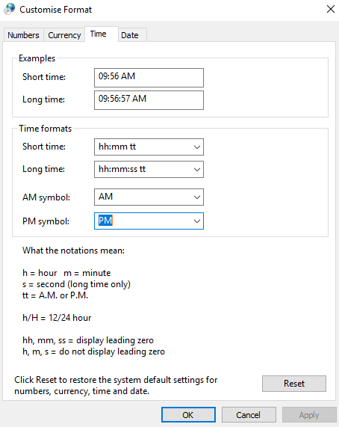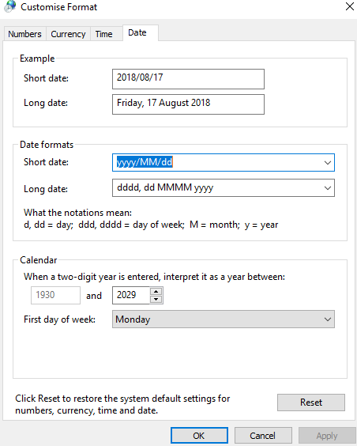
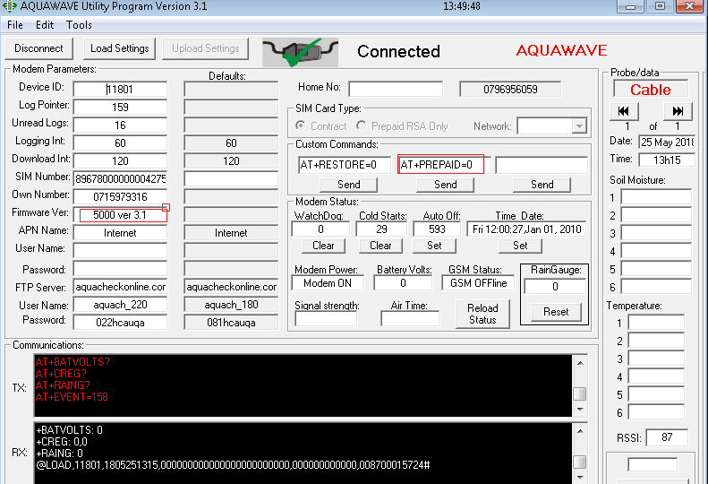
Kliek op Connect, Load Settings. Verander soos volg:
AT+PREPAID=0
FTP Server: aquacheckonline.com
Username: aquach_220
Password: 022hcauqa
Kliek op Upload settings

