**Windows Date/Time format:**

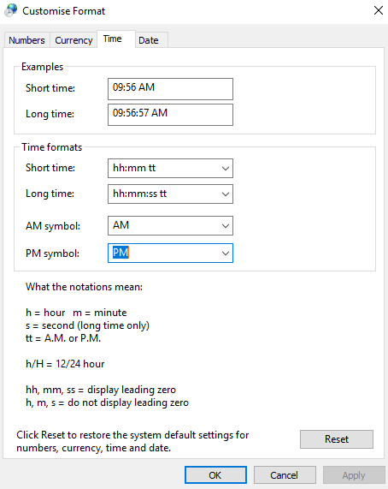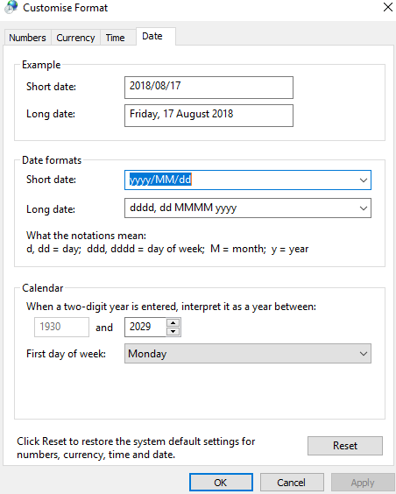

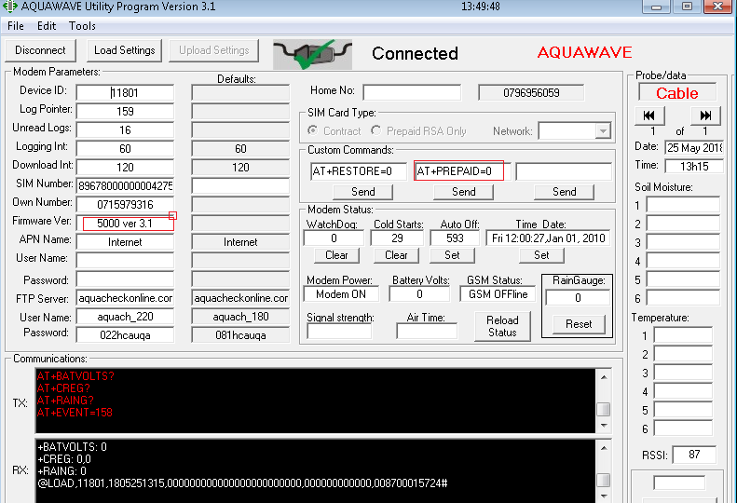

Kliek op Connect, Load Settings. Verander soos volg:

AT+PREPAID=0

FTP Server: aquacheckonline.com

Username: aquach_220

Password: 022hcauqa

Kliek op Upload settings